Section 2, Airbnb

**Market Research Report**

**To help Airbnb improve customer experience and satisfaction**

Date of Completion: December 15, 2022

Completed By: Apoorva Dudani, Maame-Yaa Kesewaa, Matilda Olu-Jordan, Sakura Nishihaya, Vijay Aakash Nemakal

Completed For: MSMI Survey Research Class

Contents

1. **Executive Summary** 4

1.1 What were the Key Findings from the Research Study? 4

2. **Description of the Problem** 4

2.1 Research Objectives 4

2.2 What were the key questions? 5

3. **Research Methodology** 5

4. **Research Study Results** 6

4.1 Descriptive Statistics? 6

4.2 What were the Results? 6

5. **Recommendations** 7

5.1 Action Plan 7

6. **Appendix** 7

6.1 Research Tools & Data Collection Forms 7

## Executive Summary

### What were the Key Findings from the Research Study?

The following data analysis summary is the result of a project that aims to understand the general needs and struggles of Airbnb users. The overall goal of this project is to develop targeted offerings to improve the customer experience of the company.

To address the issues Airbnb faces, we found refund requests are frequently made due to **the users’ price sensitivity** and **the accommodations** **not living up to users' expectations** upon arrival. The majority also consider its high cleaning fee in the booking process. Therefore, we investigated the main demographic that is more likely to associate with these problems and the followings are our key findings:

* 71% of respondents are leisure travelers
* 72% earn low-middle income with up to $75,000 annually
* 80% of respondents travel as a group: family 65%, friends 14%, and travel group 1%
* Women who are Millennials and Gen X tend to use Airbnb and often travel with families
* ‘Past experience’ and ‘curiosity’ are the primary reason for a vacation destination
* Self-check-in ranked as a top priority amenity for leisure and business travelers (10%) which indicates they prefer a speedy check-in process without any interaction as they highly value their time and privacy
* Availability of safety equipment leads to better satisfaction
* 65% of respondents booked last Airbnb accommodation located nearby an entertainment district (restaurants, cinemas, parks, museums and etc.)

## Description of the Study Goals

### Research Objectives

The key goals of our survey were to determine what consumers know about the brand Airbnb, feel about their stays in Airbnb, and how both of those things help determine how they behave towards the brand.

Our objective is to gather and mine the data in order to explore relationships between various factors and variables. This, in turn, will help us form recommendations for Airbnb to improve its customer experience and satisfaction.

### What were the Key Questions?

Here are the questions that were answered by the research study:

* What is the estimated mean importance level with every home amenity between customers with different travel purposes?
* Are customers who travel to a destination based on available Airbnbs likely to stay at an Airbnb if it is close to a tourist attraction?
* How satisfied are you with the property in relation to the safety measures?
* What is the estimated mean satisfaction level with safety according to whether a smoke alarm is available? Is there an important difference in mean satisfaction level between these groups?
* For customers that cite social media as a primary reason for choosing a vacation destination, is there a relationship between age and income?
* Is there a relationship between customers who regretted how much they paid for a stay and customers that have requested a refund?
* Is there a relationship between customers who hesitate before booking their stay because of the high cleaning fee and how well they clean the property before checking out?
* Is there a relationship between self-check-in_importance and no_privacy_refund_reason?
* Consumers that like to self-check-in without a host are not likely to request a refund due to lack of privacy.
* Thus, hosts who have the self-check-in option need not worry about refund concerns from guests who use such options.
* However, Airbnb hosts must encourage hosts to ensure maximum privacy to avoid bad ratings and reviews.

## Research Design & Methodology

### Research Methodology

3.1.1 Research Sample

Our sample size was 201, although we received 826 responses until the very end.

3.1.2 Research Methods

To be able to gather the most relevant results, our data collection method was conducting an online survey.

3.1.3 Research Design

We divided carefully designed survey questions among five different components (list format) , including general travel purpose and preference, destination factors, amenities, budget and expenses, and satisfaction with customer service, and included a minimum of 15 for each. These questions helped us understand the perceptions of the Airbnb customers in each of the main aspects that affect satisfaction and overall experience.

3.1.4 Methods of data collection

After codifying our questions, variables, and response options, we added our questionnaire to Qualtrics and uploaded it to paid survey websites.

3.1.5 Methods for data analysis

We gathered the data in a .csv file and cleaned it, removing the fields that are not relevant to our goals and research questions, and relabeling the response options. Then, based on the type of response options (such as nominal/ordinal) and variables (such as categorical/numeric), we conducted several statistical tests on the data: chi-square test, t-test, correlation test, and ANOVA test.

* Research Question 1: What is the estimated mean importance level with every home amenity between customers with different travel purpose
* Research Question 2: Are customers who travel to a destination based on available Airbnb’s likely to stay at an Airbnb if it is close to a tourist destination.
* Research Question 3: How satisfied are you with the property in relation to the safety measures?
* Research Question 5: For customers that cite social media as a primary reason for choosing a vacation destination, is there a relationship between age and income?
* Research Question 6: Is there a relationship between customers who regretted how much they paid for a stay and customers that have requested a refund?
* Research Question 7: Is there a relationship between customers who hesitate before booking their stay because of the high cleaning fee and how well they clean the property before checking out?

## Research Study Results

### Descriptive Statistics

Provide the sample size and sample descriptive statistics (graphs are good). 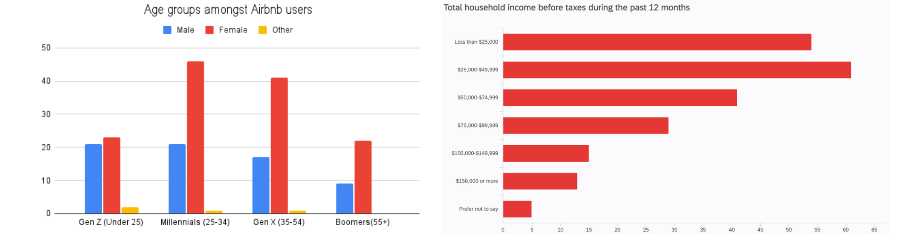

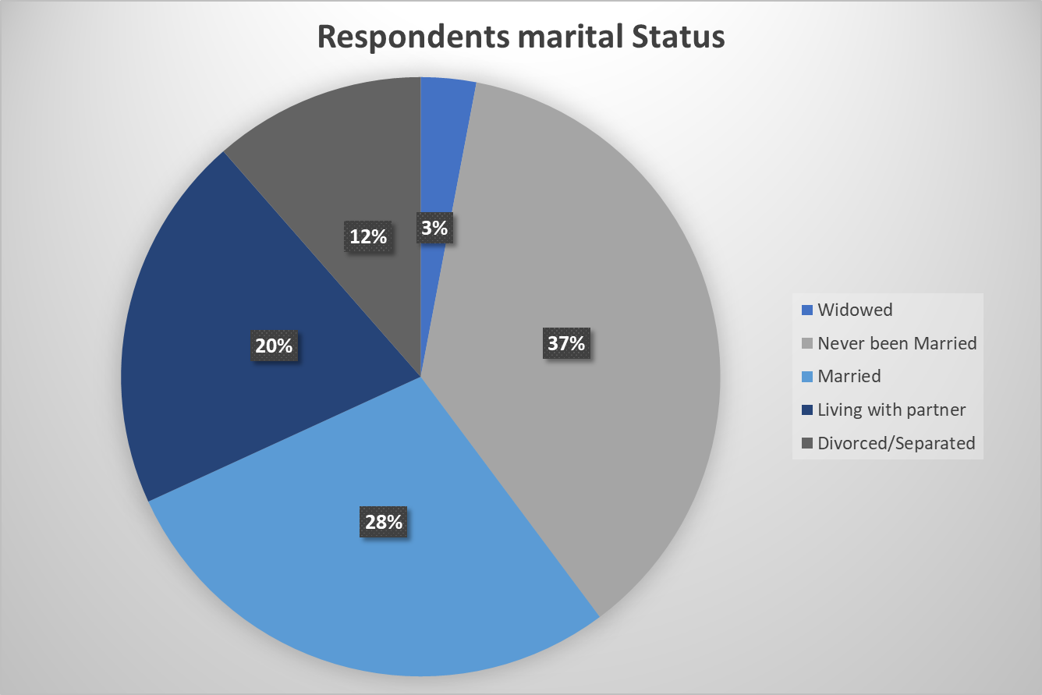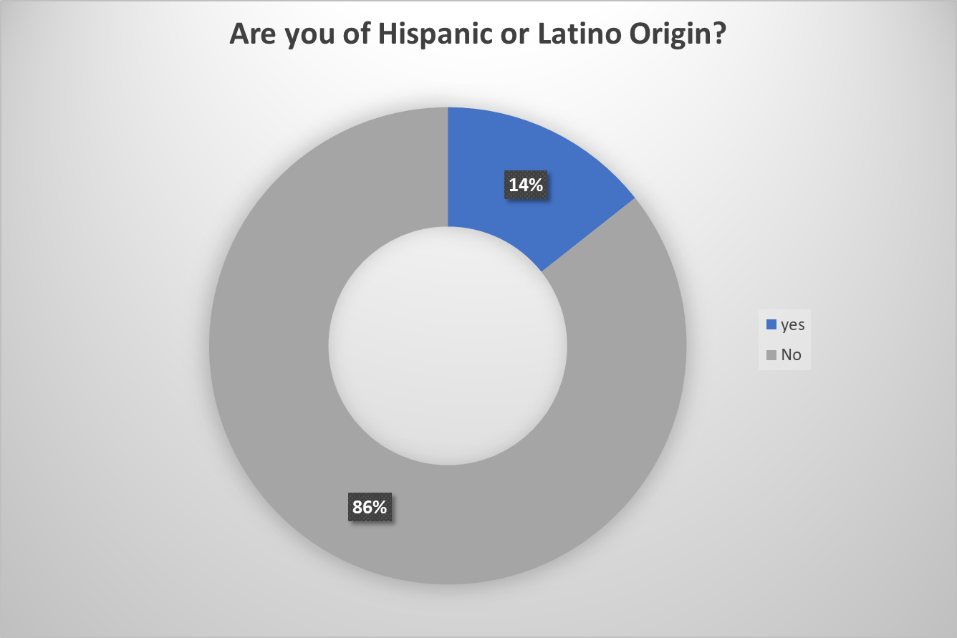

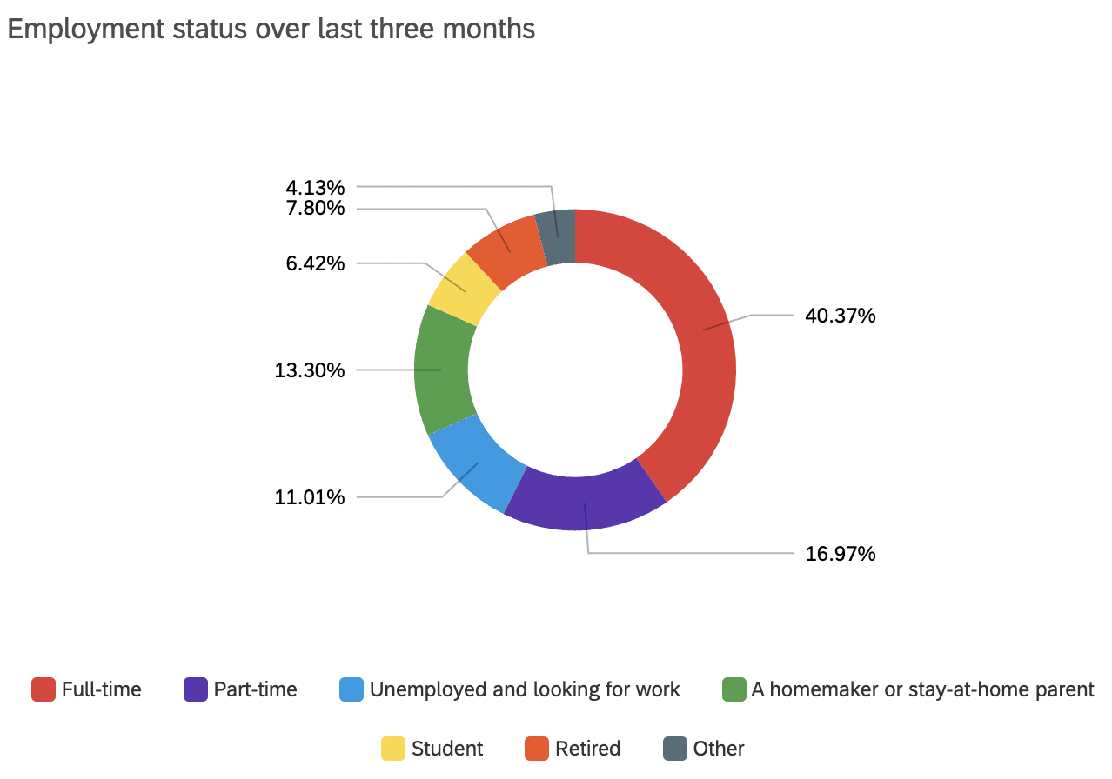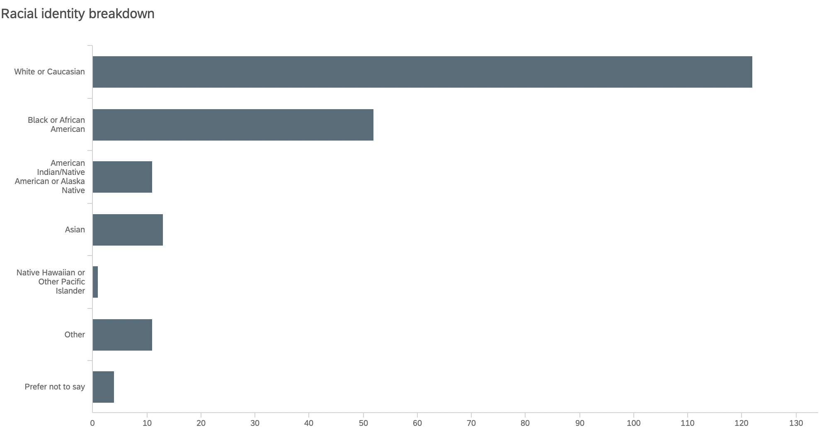

### What were the Results?

**Findings**: for the analyses presented in this report, provide a description of the results (what were the decisions for the analyses run (reject the null/fail to reject the null).

**Interpretation**: what are your interpretations of the findings (i.e., what does it mean that a test was rejected or not)?

**Implications:** Based on the interpretations, provide a detailed description of the business implications (opportunities or threats). **The implications of the results are the most important section of the report; be sure to provide lots of insight here**.

**Research Component 1**: To identify the preference of home amenities amongst different types of Airbnb users:

**Findings:** We **reject the null hypothesis** because there is a relationship between travel.purpose and amenity importance level.

**Interpretation:** When it comes to booking Airbnb accommodation, there are preferred home amenities amongst different types of travelers but amenities like wifi, kitchen, parking, air conditioning and heating are indiscriminately important for all travelers surveyed. The jacuzzi is, however, seen as the least essential amenity.

|  |  |  |
| --- | --- | --- |
| **Travel Purpose** | **Most Important** | **Least Important** |
| **Business** | Self check-in | Jacuzzi, Workplace |
| **Leisure** | Self check-in | Jacuzzi, Workspace, ADA accessibility |
| **Education** | Workspace, Pet-friendliness, ADA accessibility | Jacuzzi, Self check-in |
| **Event/concert** | Laundry | Pool, Jacuzzi, Workspace |
| **Medical** | Laundry, Self check-in, ADA accessibility | Pool, Jacuzzi |

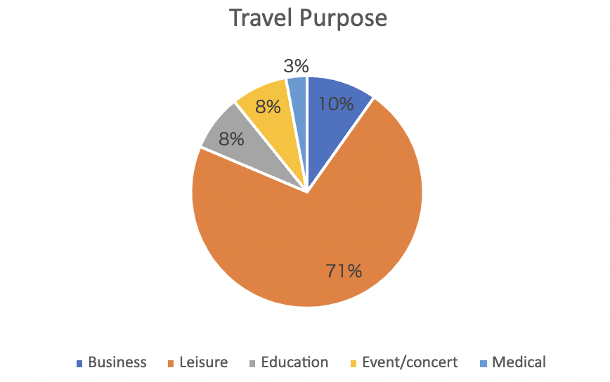

fig 3

**Implication:** According to survey results, 71% of those who have booked Airbnbs in the past, are leisure travelers, thus Airbnb should list accommodations with self-check-in, wifi, kitchen, parking, air conditioning, and heating as a top priority. Although ADA accessibility may be the least demanded for leisure travelers, it should also be considered as a higher priority for listing in order to provide the same rights and opportunity to those in need. Besides that, ADA accessibility is an important factor for education and medical travelers.

**Recommendation:** To meet the varying preferences of travelers, Airbnb must add a “type of traveler” feature to the search engine to offer the traveler options tailored to their preferences during their search for Airbnbs.

**Research component 2**: To determine if customers travel to destinations based on tourist attractions.

**Findings**: p-value = 4.658e-08, The p-value is smaller than alpha (0.05), so we can reject the null hypothesis

**Interpretation**: There is a relationship between tourist_stayed and airbnb_availability_influence.

**Implication**: There is a probability for those who travel to a destination based on available Airbnbs to stay at an Airbnb if it is close to a tourist attraction.

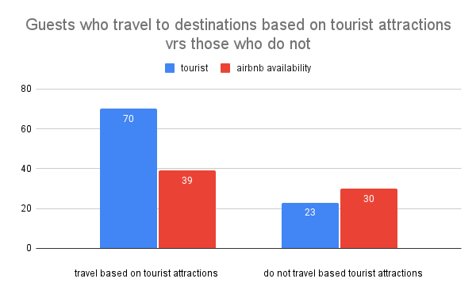

fig 4

**Recommendation**: Airbnb can curate a travel package that has an all-inclusive feature, i.e. a discounted price for Airbnb close to these tourist attractions, travel guides, discounts on Uber Eats and transportation. For the latter, Airbnb can collaborate with cities of popular tourist attractions to offer free transport passes and reduced gate fees at tourist centers. Alternatively, Airbnb can join forces with transport services like Uber & Lyft to give riders discounted rides during their entire stay.

**Research Component 3:** To measure how satisfied Airbnb customers are with the property in relation to the following safety measures?

**Findings:** p-value = 0.005125

The p-value is lesser than alpha, so we reject the null hypothesis

**Interpretation:** We conclude that there is a difference in mean safety satisfaction level between Airbnbs who have smoke alarms and those who do not.

**Implication**: Airbnb guests are generally less satisfied when safety equipment such as smoke alarms and first aid kits are not available in a property.

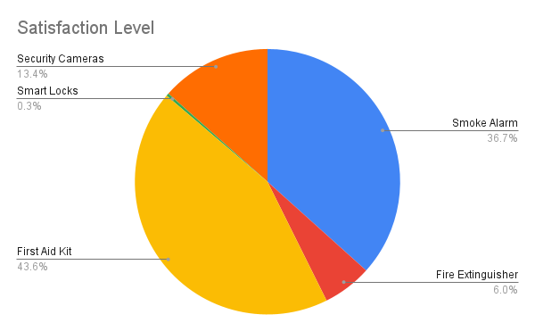 fig 5

**Recommendation**: To guarantee better satisfaction and reviews from residents, it will be beneficial for Airbnbs to encourage hosts to have smoke alarms installed and first kits readily available on the property. This will assure customers of their safety.

**Research component 4: To Identify if there is a relationship between age and income for those who see social media as an influence to make vacation decisions.**

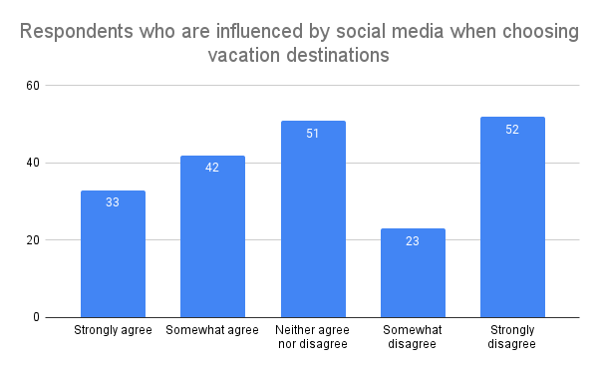

fig 6

For customers that cite social media as a primary reason for choosing a vacation destination, is there a relationship between age and income?

**Findings:** p-value = 0.9733

The p value is greater than alpha, so we do not reject the null hypothesis.

**Interpretation:** There is a relationship between age and income for customers that cite social media as a primary reason for choosing a vacation destination.

**Implication**: For customers who choose a vacation destination based on social media influence, demographic factors such as age and income are not related to their choice for a vacation decision.

**Recommendation**: Any promotion or marketing efforts on social media need not take the age and income levels of the customer into consideration.

**Research Component 5**: To determine if a customer that regrets how much they spent on a stay is also likely to request a refund.

Is there a relationship between customers who regretted how much they paid for a stay and customers that have requested a refund?

**Findings:** The analysis resulted in ap-value of 0.001101 which is smaller than the alpha, so we reject the null hypothesis and conclude that variables *Remorse* and *Refund* are dependent.

**Interpretation:** Our analysis shows that there is a relationship between customers who regret the amount of money they paid for a property (*Remorse*) after arriving at the property and customers who have requested a refund (*Refund*).

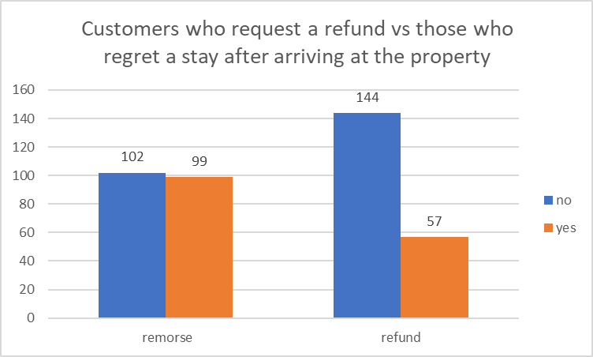fig 7

**Implication**: What our analysis shows us is that guests are more likely to request a refund from Airbnb if the property does not meet their expectations upon arrival. Based on the survey, we know that almost half of the respondents, 49%, feel regret for the amount of money they paid after arriving at the property. Even though the actual percentage of respondents who have requested a refund is 28%, there is still a possibility for them to request a refund. For Airbnb, this is not good news as it directly ties consumer expectations to potential loss of revenue for the company and indirectly to lower consumer satisfaction.

**Recommendation**: To better understand why guests may feel regret after arriving at the property, Airbnb should seek to learn what expectations are not being met by the hosts or property. They should seek to ensure that all photos match the property as well as whatever listings are offered. Additionally, Airbnb can consider offering virtual /video tours so that guests know exactly what to expect when they arrive at the property thereby reducing the possibility of feelings of regret and consequently the possibility of a refund request.

Airbnb can also offer the guests discounts towards their next booking when issuing refunds. These discounts could come in the form of coupon codes, points added to their account or percentages off. This move has the potential to help retain customer loyalty to Airbnb as a brand, so they don’t shift to other competitors.

**Research component 6**: To determine if consumers that like self-check-in are also likely to request a refund due to lack of privacy.

Is there a relationship between *self-check-in_importance* and *no_privacy_refund_reason*?

**Findings:** We arrived at ap-value of 0.3379 in our analysis which is smaller than the stated alpha, so we reject the null hypothesis and conclude that variables *self-check-in_importance* and *no_privacy_refund_reason* are dependent.

**Interpretation:** For guests who request refunds, there are different reasons, however, respondents who prefer the self-check-in process (*self-check-in_importance)* are more likely to request refunds due to privacy reasons (*no_privacy_refund_reason*).

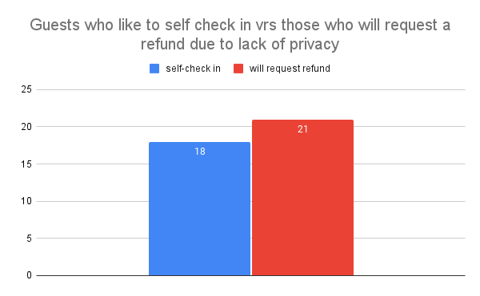fig 8

**Implication**: Consumers that like to self-check-in without a host are not likely to request a refund if they feel their privacy is invaded.

fig 9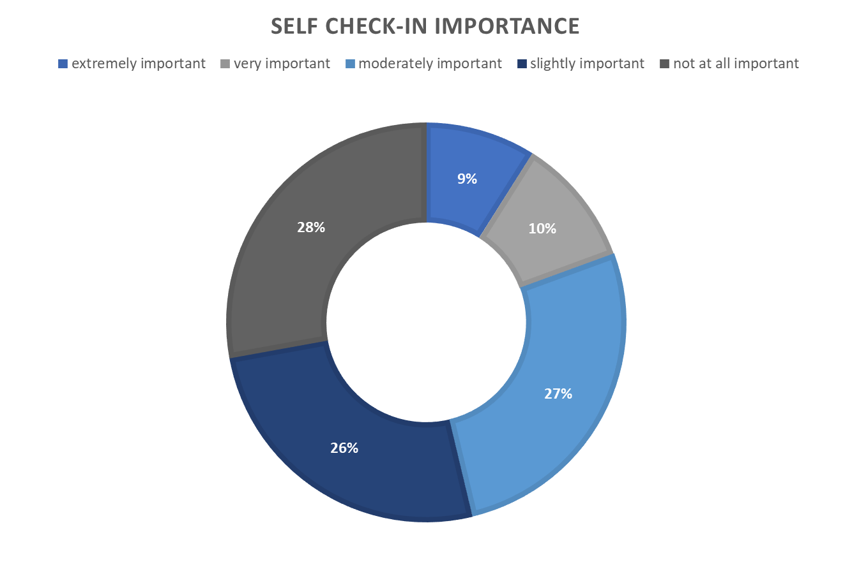

**Recommendation**: Hosts who have the self-check-in option need not worry about refund concerns from guests who use self-check in. However, Airbnb must encourage hosts to ensure maximum privacy regardless.

## Conclusion

As customer satisfaction is heavily associated with their investment and expectations, we suggest Airbnb develop new search features based on a type of traveler in order to meet users’ specific needs and optimize the booking process. In addition, to minimize users’ confusion regarding the inaccuracy of listing information, Airbnb should provide hosts with a support program periodically to ensure that their hospitality is catering to customer expectations with the highest precision possible. Furthermore, we recommend Airbnb establish a clear set of standards for property safety in order to enhance customer experience.

## Appendix

### Research Tools & Data Collection Forms

Attach all the documents used during your study, including project plan, surveys, respondent demographics, data collection tools, third-party reports.

Project plan: Codebook

Data collection tool: 

Survey:

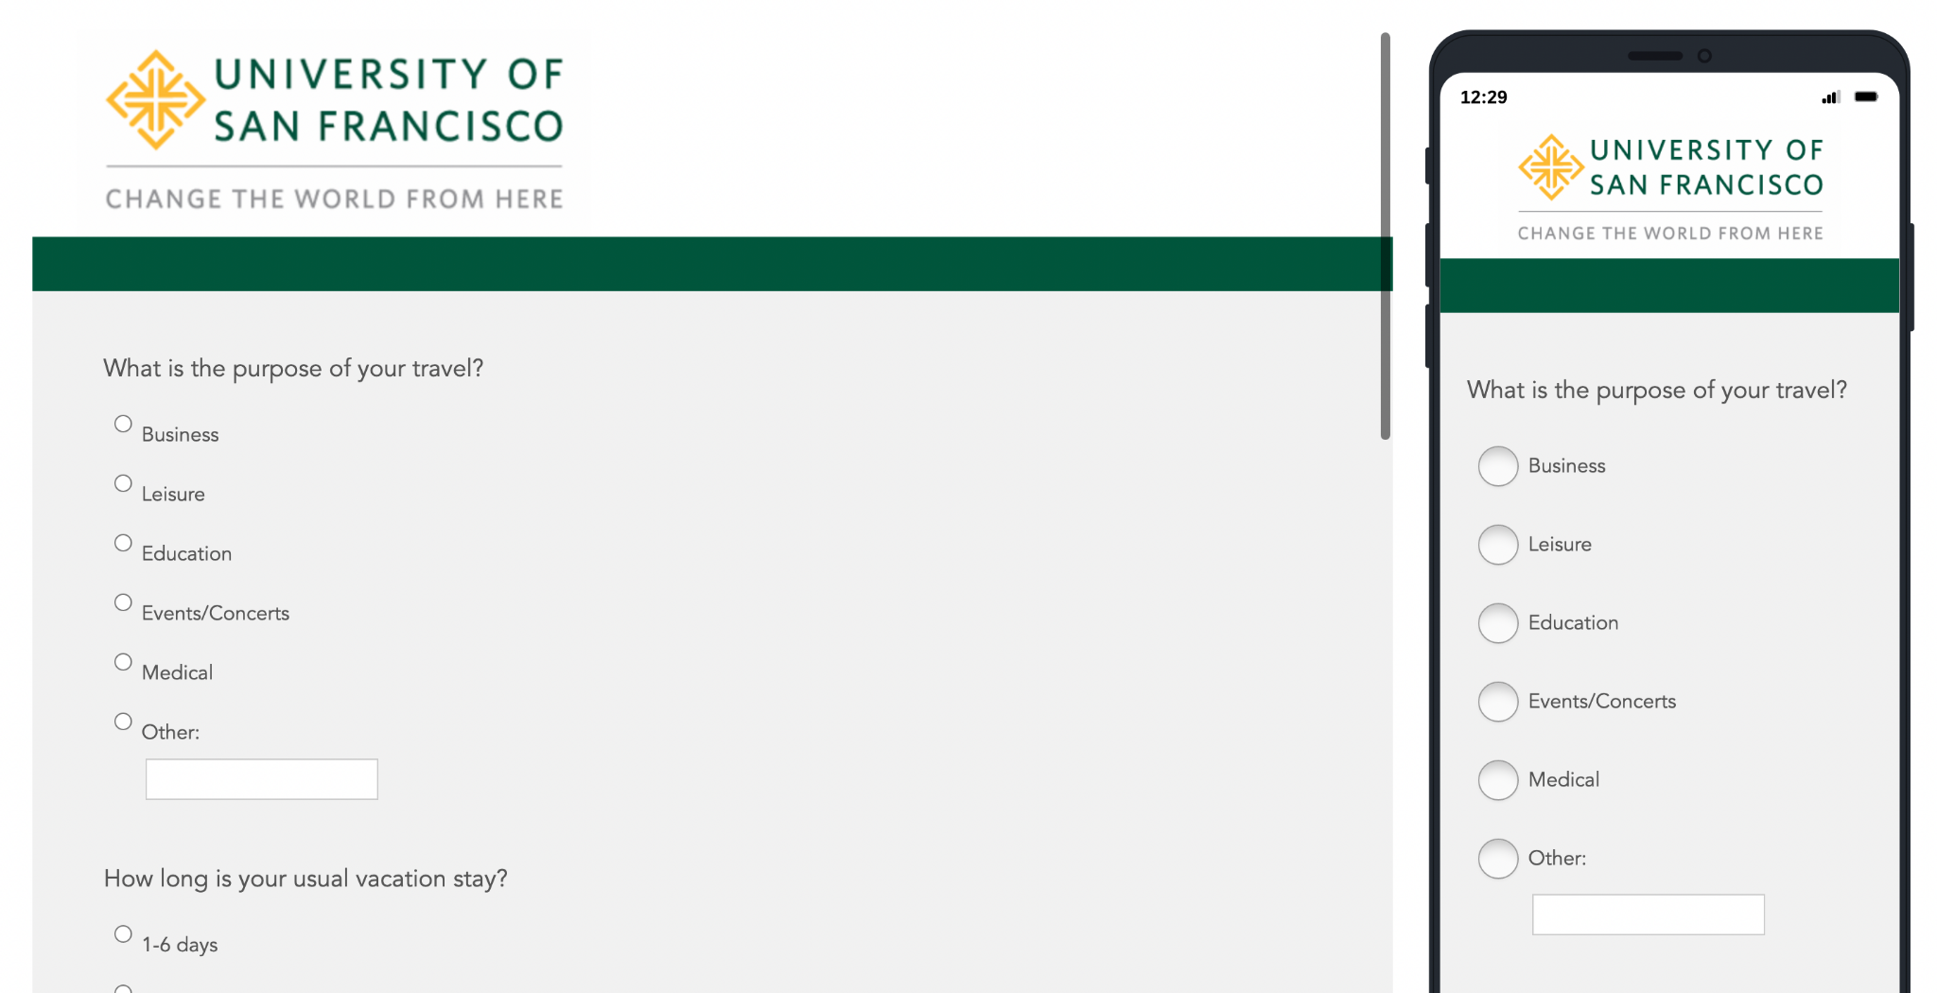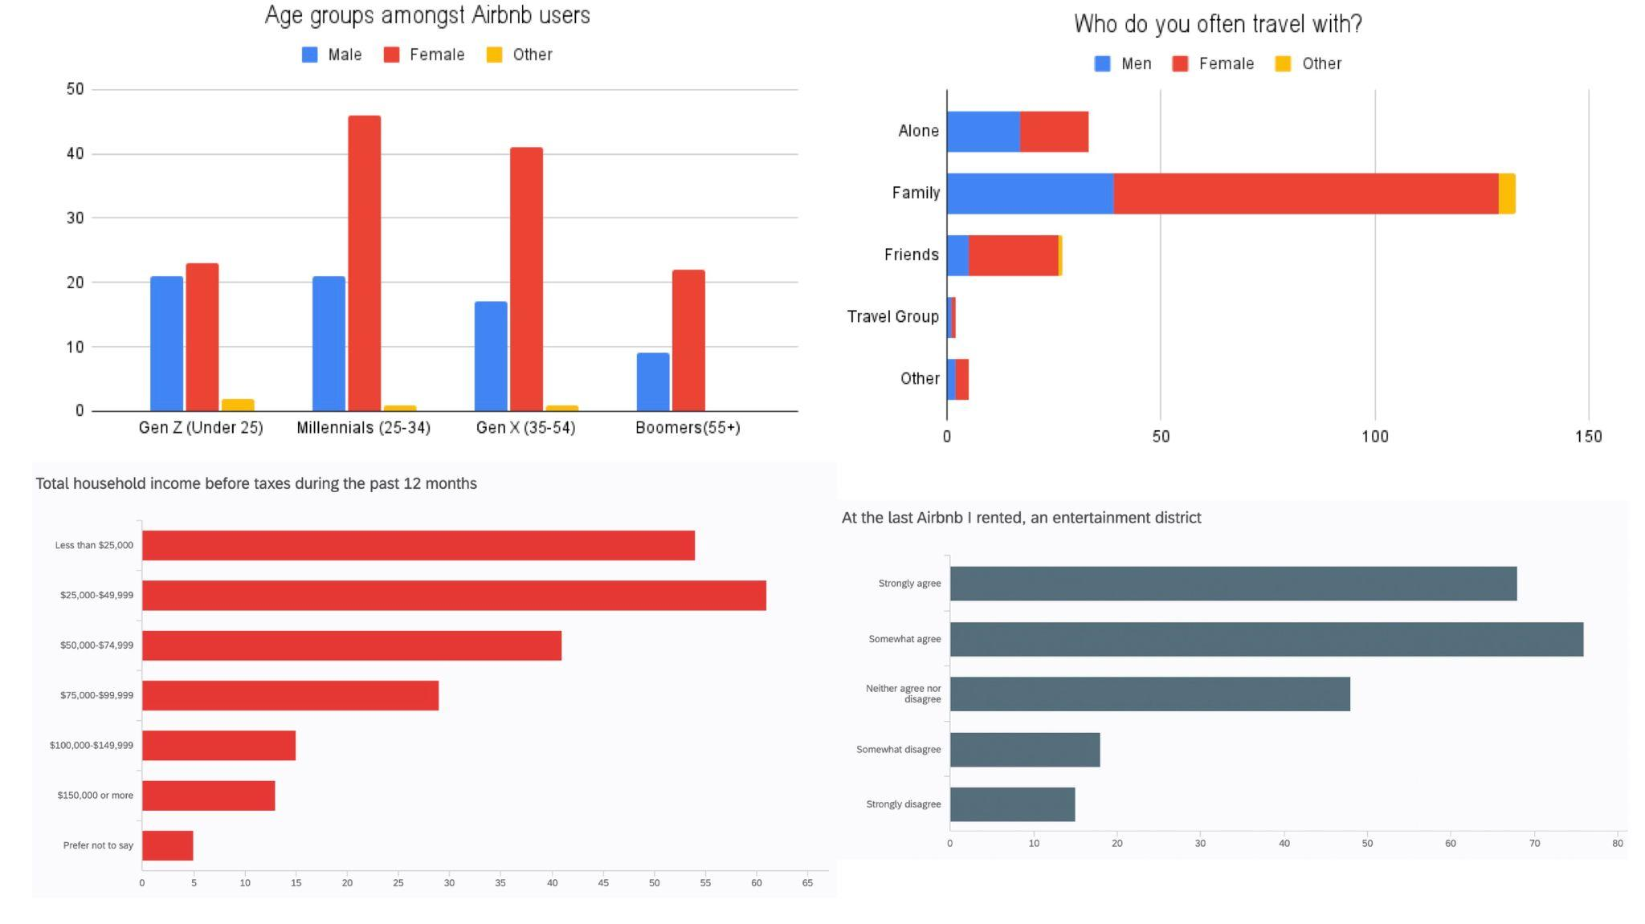

Data:

